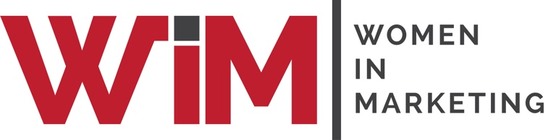

Entry Form

Women in Marketing Awards 2022
Category: Equality Advocate of the Year

Please complete your contact details below and provide supporting statements for you and/or your team as a candidate in this category. Self and third-party nominations are welcome, and this category is open to brand and agency marketers.

The Equality Advocate of the Year Award will be given to a male, who has proved to be an equality advocate throughout the year in their role in marketing. This will be a male who inspires equality, who challenges the norms of marketing, is passionate about the development of people within the industry and whose energy and commitment has delivered outstanding results. Nominations are welcome; the judges will decide the worthy candidate.

Once completed, please upload your form and any supporting materials (jpegs, PDFs) to womeninmarketing.org.uk

Nominee details
Name of nominee
Organisation
Address
Email
Telephone
Self-nomination | YES / NO
 | If NO, relationship to nominee:
Is nominee aware of this application? | YES / NO

Profile of the nominee for event marketing purposes.
Please include, if known, the size of company, number of staff, length of time in the role.
30 words

REASONS FOR NOMINATION
750 words

TESTIMONIALS
The submission should be supported by no more than 3 testimonials from those in a position to validate the candidate’s commitment to being an equality advocate.

SUPPORTING MATERIAL
Please list the attachments being uploaded with the entry (jpegs, PDFs)
Please include a logo of the company and a photograph of the candidate for marketing purposes.

