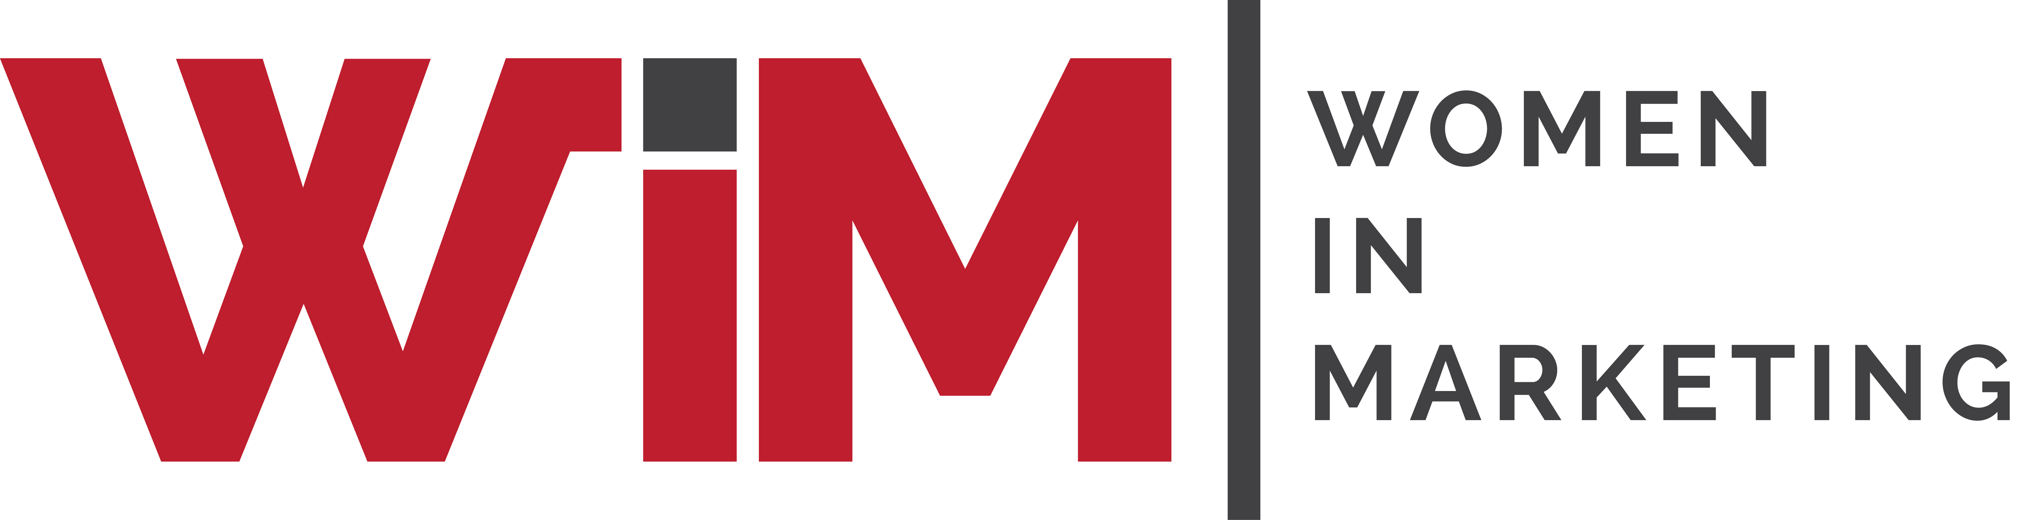

Entry Form

Women in Marketing Awards 2025
Category:PR Communicator of the Year

Please complete your contact details below and provide supporting statements for you and/or your team as a candidate in this category. Self and third-party nominations are welcome.
This category aims to highlight the important role of PR and communications for a brands reputation in the conversation era. This award recognises female PR industry leaders-agency and client side.
Judges will be seeking evidence of impactful initiatives in one’s organisation and or for clients professional related achievements, actions providing leadership in the PR sector, and ideally contributions to the evolution of the wider marketing/communications industry in regard to trust and crisis management.
Once completed, please upload your form and any supporting materials (jpegs, PDFs) to womeninmarketing.org.uk
Nominee details
Name of nominee
Organisation
Address
Email
Telephone
Self-nomination
Is nominee aware of this application?
Are you applying for the agency or client-side category?

Description of your organisation, your/nominee’s job title and role and the size of the team
30 words
.

Tell us about your/nominee’s career journey so far, focusing on career highlights that sets you/the nominee apart.
150 words
.

.

What are your/ the nominee’s biggest professional achievements or key initiatives over the last year that are worthy of a WiM award in this specific category?
200 words
.

Are there any specific, tangible data and/ or results that you can mention to support the above?
100 words
.

Are there any personal circumstances or other elements the jury should consider that make the above professional achievements even more significant?
100 words

How have your/the nominee’s initiatives or actions demonstrated leadership in the PR sector and contributed to the evolution of the wider marketing/communications industry?
200 words
.

