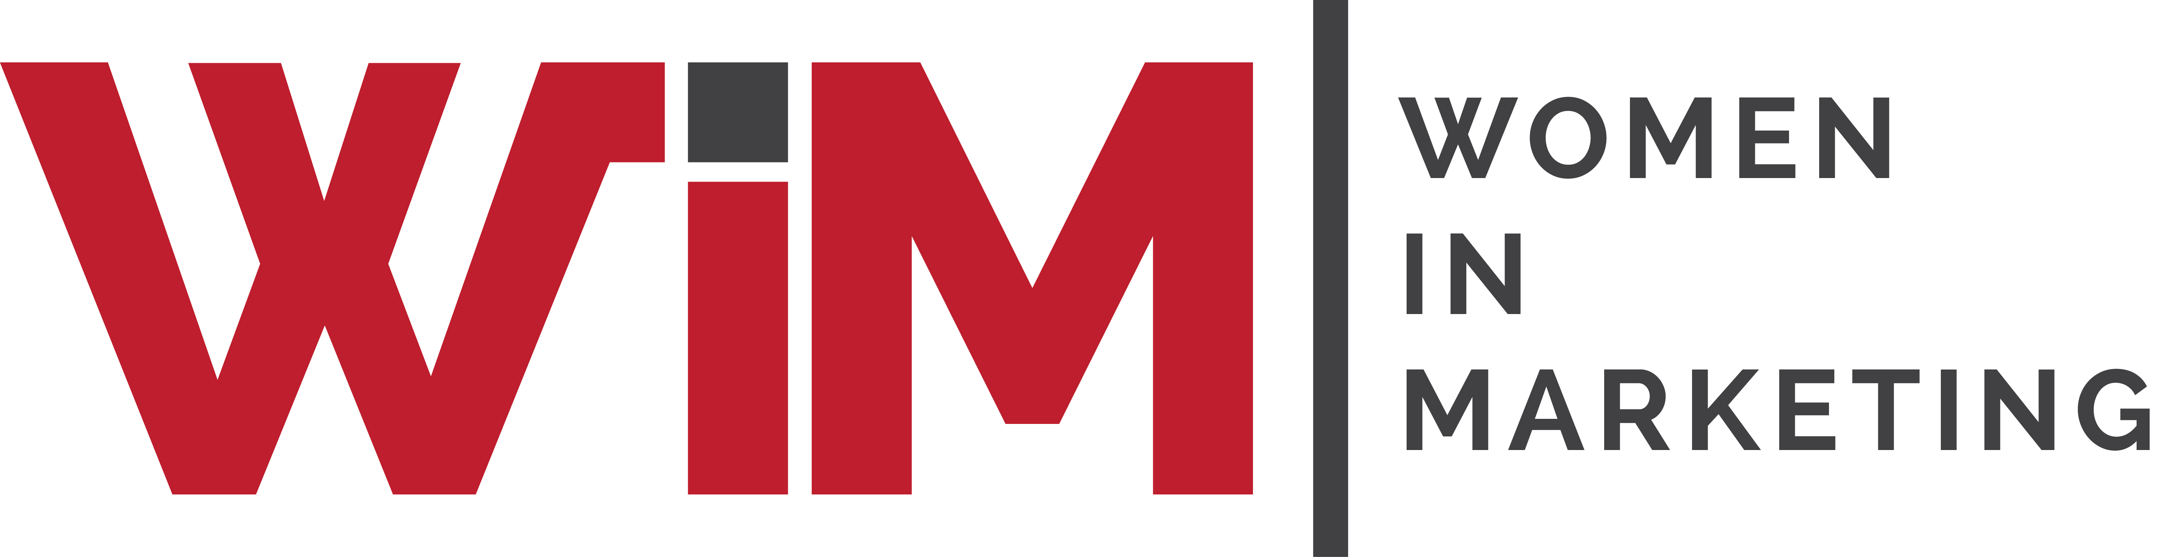

Entry Form
Women in Marketing Awards 2025
Category: The Copywriting Award - Supported by #copywritersunite

Please complete your contact details below and provide supporting statements for you and/or your team as a candidate in this category. Self and third-party nominations are welcome.

This award recognises the craft of copywriting. The winner will be awarded for her way with words: words that lean on effective copywriting techniques to be clear, creative, concise and compelling.
Entries should be copy written for a client and produced in the last year. On packaging, on billboards or online. In print, in social or internal comms. A tiny banner ad or a huge campaign.
Particular consideration will be given to copywriters who have created a campaign or initiative, either independently or for a client, that uses the power of words to empower women, encourage equality or fight gender discrimination.

Once completed, please upload your form and any supporting materials (jpegs, PDFs) to womeninmarketing.org.uk

Nominee details
Name of nominee
Organisation
Address
Email
Telephone
Self-nomination | YES / NO
 | If NO, relationship to nominee:
Is nominee aware of this application? | YES / NO

Profile of you or your team for event marketing purposes.
Please include a short bio and links to your website,portfolio site,LinkedIn/Dots/other profile
30 words

Rationale

Please write a short rationale for your entry eg.any relevant context like a summary of the brief/ or objectives
100 words

Craft

Please write a short description of your approach and desired impact on the audience
200 words

Copywriting
Please list the attachments you are sending as your entry( J pegs PdF’s)

Please provide a link to or upload the campaign materials. Please can you also include a logo of your company and a photograph of yourself for marketing purposes.

