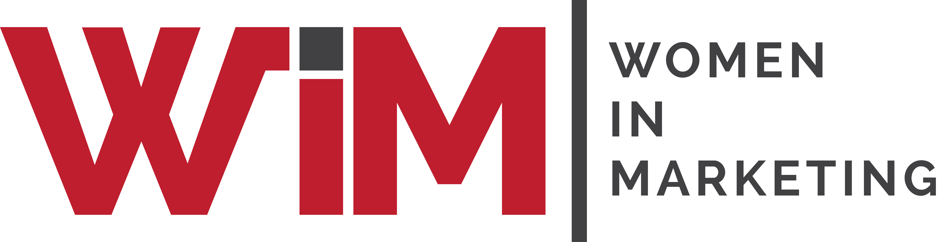

Entry Form

Women in Marketing Awards 2025

Category: The Independent Consultant

Please complete your contact details below and provide supporting statements for you as a candidate in this category. Self and third-party nominations are welcome, and this category is open to brand and agency consultants.
The Independent Consultant award recognises someone who demonstrates a comprehensive understanding and application of marketing best practice, ambition and innovation in their role as independent marketing consultant.
Once completed, please upload your form and any supporting materials jpegs / PDFs to womeninmarketing.org.uk
Nominee details
Name of nominee
Organisation
Address
Email
Telephone
Self-nomination | YES / NO
 | If NO, relationship to nominee:
Is nominee aware of this application? | YES / NO
Are you applying for the brand or agency-side category | Brand / Agency

Profile of you for event marketing purposes.
Please include, if known, the size of marketing budget and company turnover 30 words

INSPIRATION AND ACHIEVEMENT
Please explain your career path to date, motivation for working as an independent consultant and approach to the discipline. 300 words

VALUE AND RESULTS
Please give examples of your work and the value they have brought to clients 300 words

CAMPAIGN EXECUTION
Please explain and give examples of how you have demonstrated a comprehensive understanding and application of marketing best practice, ambition and innovation, as well as showing a notable growth and development of your business practice and client list. 300 words

RECOGNITION
Please provide supporting testimonials from clients and/or colleagues, verifying the success you have achieved. 300 words

SUPPORTING MATERIAL
Please list the attachments you are uploading with your entry (jpegs, PDFs)
Please include a logo of the company and a photograph of the candidate for marketing purposes.

