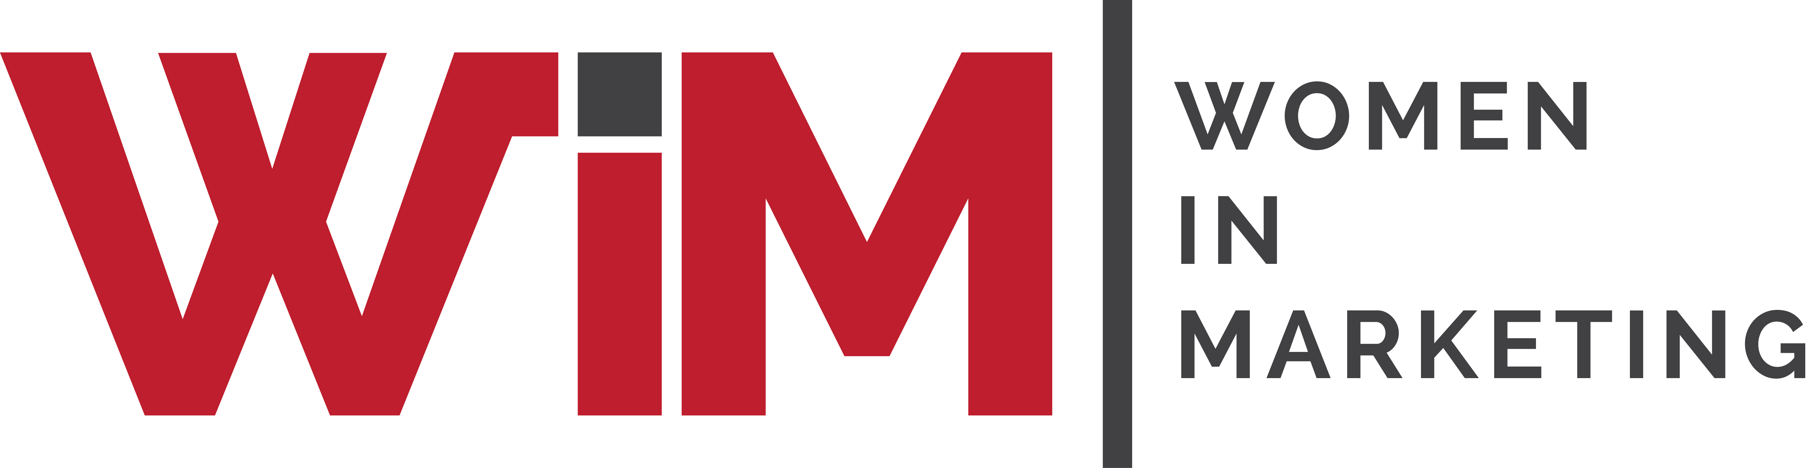

Entry Form
Women in Marketing Awards 2025
Category: The WIM AI for Impact Award(NEW)

Please complete your contact details below and provide supporting statements for you and/or your team as a candidate in this category. Self and third-party nominations are welcome, and this category is open to client-side, agency professionals and independents.

The WIM AI for Impact Award recognises a woman who leads at the intersection of AI, marketing, innovation and social impact. This award celebrates those who not only pioneer AI driven marketing strategies but also champion ethical inclusive, inclusive and equitable AI practices.

NB: Please read and adhere to the category descriptor and criteria before answering the questions.

Once completed, please upload your form and any supporting materials (jpegs, PDFs) to womeninmarketing.org.uk.

Nominee details
Name of nominee
Organisation
Address
Email
Telephone
Self-nomination
Is nominee aware of this application?
Are you applying for the agency or brand-side category/other

Description of your organisation, your/nominee’s job title and role and the size of the team
30 words
.

Achievements &Initiatives:
What are the nominees most significant professional achievements or key initiatives in the past year related to AI in marketing
(up to 300 words)

How does the nominee’s approach to marketing differ from the traditional method particularly in advancing inclusion and equity?
300 words

Innovation Outcomes:
What specific results or examples illustrate the impact of the nominees work with AI? Consider- the effectiveness, efficiency, creativity, inclusion, social equity
300 words

Ethical and Social Impact:
How has the nominee assured that AI marketing strategies address biases? In what ways has the nominee’s leadership accelerated gender parity/social equity
.

Please include a high-res head shot and company logo.

