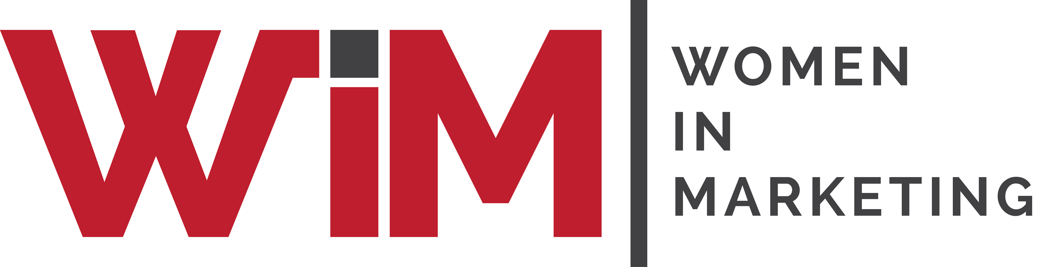

Entry Form

Women in Marketing Awards 2025
Category: The WIM Company of the Year Award

Please complete your contact details below and provide supporting statements for you and/or your team as a candidate in this category. Self and third-party nominations are welcome, and this category is open to brand and agency marketers.

Once completed, please upload your form and any supporting materials (jpegs, PDFs) to womeninmarketing.org.uk.

This award recognises an organisation that actively supports the development and establishment of women in senior marketing leadership roles and demonstrates best practices in diversity and inclusion throughout their organisation.
The organisations nominated can range from commercial businesses to agencies to academia.
The winning organisation needs to demonstrate that it has women in senior leadership roles along with a clear strategy and plan to increase that number. The organisation also needs to demonstrate its journey towards inclusion and diversity, drawing inspiration from the WiM Inclusion Charter with the aspirational ethos of #WeWill – a willingness to join the inclusion journey and share best practice, and through coming together we can succeed and challenge the status quo.

Name of nominee
Organisation
Address
Email
Telephone
Are you applying for the agency/brand/other category | Agency / brand/other

Biographical profile about the nominee for event marketing purposes.
Please include, if known, the size of company and type of company/organisation (30 words)

REASONS FOR NOMINATION

SUPPORTING MATERIAL
Please list the attachments you are sending with your entry (jpegs, PDFs, audio or video links only)
Please include a logo of your company for marketing purposes.

