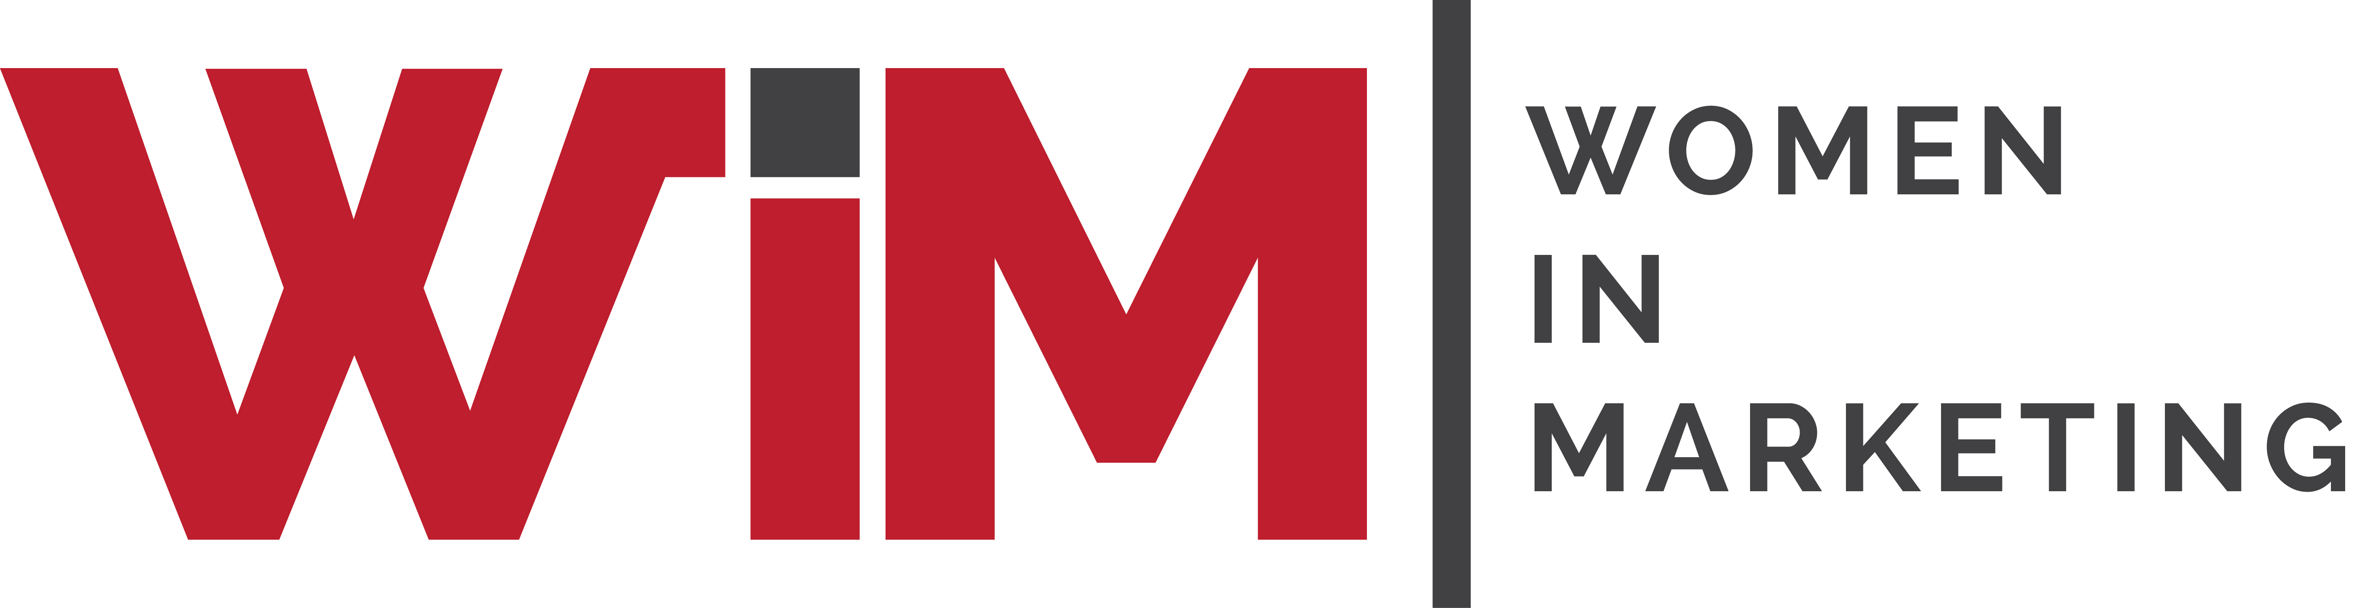

Entry Form

Women in Marketing Awards 2025
Category: The WIM Social Impact Award (NEW)

Please complete your contact details below and provide supporting statements for you and/or your team as a candidate in this category. Self and third-party nominations are welcome, and this category is open to brand and agency marketers.

Once completed, please upload your form and any supporting materials (jpegs, PDFs) to womeninmarketing.org.uk.

Description | This award recognises marketing-led initiatives that have been actively designed and implemented with the goal of creating positive social impact. For the purpose of this award, the social impact is defined as evidence-based, provable positive change beyond organisational performance goals, such as wellbeing of consumers or other beneficiaries. Examples of positive change include, but are not limited to: 1) physical and/or mental health journeys wellbeing, including motherhood and parenthood, peri/during/post menopause, disability and neuro-divergency related healthcare; 2) workplace wellbeing and support of talent across generations; 3) financial wellbeing and support for wealth creation/management; 3) creativity and culture initiatives; 4) wellbeing in and via digital technologies, including digital access enhancing programmes and initiatives facilitating critical consumption of digital information; 5) empathetic complex consumption experiences such as unemployment, loss and grief, and cost of living crisis; 6) supporting youth future.  Nominees can range from individuals, brands, private or public sector organisations or specific departments/divisions within them and partnerships between these entities.  The winner(s) need to demonstrate that women have played a leading role in the development of initiatives and have women included as the main or equitable beneficiaries. The winner also needs to demonstrate its journey from ideation to implementation of the initiative, drawing inspiration from the WiM Social Impact Charter with the aspirational ethos of #WeWill – a willingness to draw on marketing as a force for social good.
Name of nominee or Team
Organisation
Address
Email
Telephone
Are you applying for the /individual/ brand/organisation or organisational division/partnership category

Biographical profile about the nominee(s) for event marketing purposes.
Please include, if relevant, the size and type of organisation(s) (30 words)

REASONS FOR NOMINATION
Please include information on the following: 1) the catalyst for initiative development – what social impact did you seek to create; 2) the process of the initiative development, including impact-related KPIs that have been set; 3) the collaborations/partnerships that have been established (if relevant); 4) how the initiative was implemented; 5) evidence of social impact (testimonial interviews, survey evaluations, videos or any other forms of evidence including but limited to those collected for KPI assessment)
Max 1,000 words in total imbed relevant links

SUPPORTING MATERIAL
Please list the attachments you are sending with your entry (jpegs, PDFs, audio or video links only)
Please include a logo of your organisation(s) for marketing purposes.

